

Control Tower System Analysis

Table of Contents

Introduction and Working Hypotheses 1

System Description 1

System Behaviour 1

Working Hypotheses 1

System Modelling 2

Queuing Theory Model (attempt) 2

Simulation Model 3

Preliminary Analysis 4

Stability Condition 4

Subsampling and Confidence Level 5

Warm-up Time 6

Statistics Distributions Fitting 7

2kr Factorial Analysis 8

System Fairness Analysis 10

Conclusions 11

Introduction and Working Hypotheses

System Description

The system under analysis consists in an airport with a single runway, which can be used by one airplane at a time for landing or take-off operations, a parking area, where airplanes are temporarily stationed between landing and take-off, and a control tower, which routes the air traffic within the airport.

System Behaviour

The system behaviour can be described as follows:

1. Airplanes intending to land reach the airport with an interarrival time “tA”.
2. Whenever an airplane intending to land reaches the airport, it enqueues for landing waiting for the authorization from the control tower.
3. As soon as authorized by the control tower, the airplane performs the landing operation occupying the runway, which completes in a time “tL”.
4. As soon as the airplane has finished landing it frees the runway and moves towards the parking area, where it will remain stationed for a time “tP”.
5. When the airplane finishes its parking time, it enqueues for take-off, again waiting for the authorization from the control tower.
6. As soon as authorized by the control tower, the airplane performs the take-off operation, occupying the runway, which completes in a time “tO”.
7. When the airplane completes the take-off operation, it leaves the system.

From here the control tower routes the traffic within the airport by authorizing the landing or take-off of the airplane having waited the longest to use the runway, assigning it to the next longest waiter as soon as the airplane completes its landing or take-off.

Working Hypotheses

The system must be analysed under the following given hypothesis:

1. The system must be analysed supposing the “tA” , “tL”, “tP” and “tO” times described above both as constants (deterministic regime) and as rates of exponential random variables (stochastic regime).
2. The airplanes awaiting landing have an infinite fuel supply, meaning that they can wait for an infinite time without the risk of crashing.
3. The parking area has an infinite airplane capacity.

The system analysis will also be based on the following additional hypotheses:

1. The system will be analysed starting from an empty state, meaning that there are no airplanes parked, landing or taking off, and where the first airplane will reach the system in a time “tA”.
2. The airplanes parking time “tP” starts as soon as they leave the runway, and comprises the time required to reach the parking facilities, to perform any passengers/cargo unloading/loading and refuelling, and to leave the parking facilities reaching a separate area adjacent to the runway, where they will wait for the authorization to take-off from the control tower. Following this description, the total number of grounded planes within the airport is given by the number of parked airplanes plus the number of airplanes enqueued for take-off.
3. Should two airplanes be ready for landing and take-off at the same exact time (which may happen both in deterministic and stochastic regime, in the latter case due to quantization roundings) the Control Tower will assign the runway to the airplane requesting to land.
4. The system time evolution strictly attunes to the behaviour described above, where real case delays such as the ones determined by the communications between the airplanes and the control tower, the ignition time of the engines prior to take-off, or the local spatial displacements of the airplanes awaiting landing or take-off are not taken into account.

System Modelling

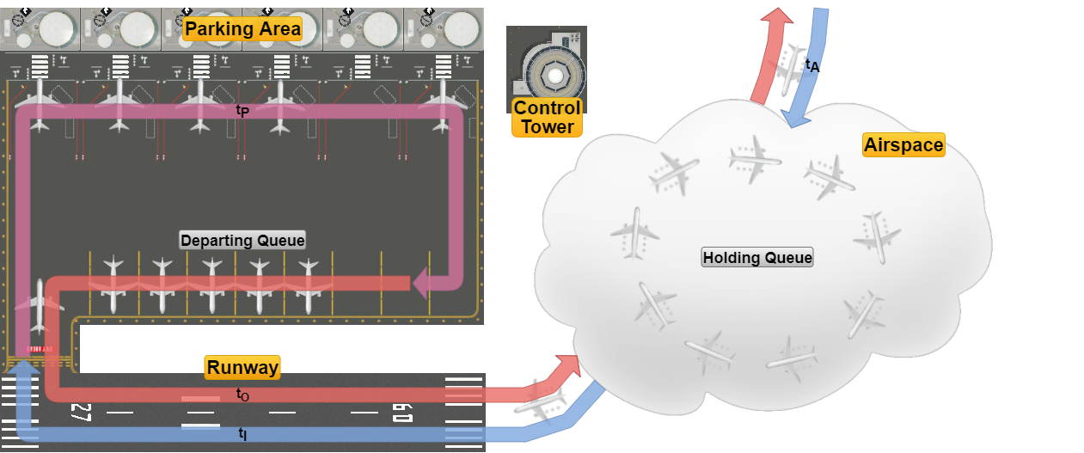

The system can be functionally divided into the following components:

* The *Airspace* surrounding the airport, where the airplanes intending to land arrive with an interarrival time “tA” and enqueue for landing in the *Holding Queue*, and where airplanes transit once they have taken off, leaving the system.
* The *Runway*, which is used mutually exclusively by airplanes for landing and take-off operations, which are performed in times “tL” and “tO” respectively.
* The *Parking Area*, which consists of the facilities where the airplanes transit through after they have landed and before they are ready for take-off, which occurs in a time “tP”, after which the airplanes enqueue in a separate *Departing Queue* adjacent to the runway waiting for the authorization to take-off.
* The *Control Tower*, which acts as a logical entity routing the traffic within the airport.

Queuing Theory Model (attempt)

The system can be tentatively described in terms of queuing theory as a classed routing network with the jobs representing airplanes divided into the two classes as follows:

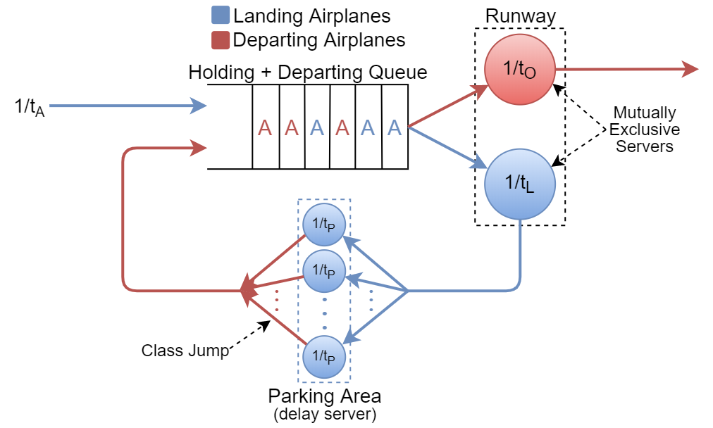

Where:

* The *Holding* and *Departing* *Queues* have been logically merged into a single virtual queue having as server the *Runway*, which in turn is divided into two logical servers with service rates ““ and ““ relative respectively to the landing and departing classes, servers whose services are mutually exclusive (i.e. just one airplane at a time can be served in the runway by the virtual server associated with its class).
* The *Parking Area* represents a *Delay Server* with service rate “”, which also switches the airplanes from the Landing to the Departing class.  
  It should also be noted that, representing a Delay Server, the *Parking Area*’s parking time “tP” will have no effect on the system’s stability, as is thoroughly discussed later in the document.
* The *Control Tower*, being a logical entity, finds no correspondence in the model.

From here, since we are unable to determine the steady-state equations of the network and thus its performance metrics, in order to analyse the system the use of a simulation software is required.

Simulation Model

The simulator software used is OMNeT++ 5.5.1, wherein the system model was reproduced as follows:

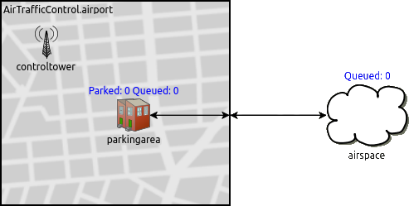

Where:

* The *airspace*, the *parkingarea* and the *controltower* represent simple modules, the last two being logically grouped inside an *airport* compound module representing the airport grounds.
* The *runway* represents the connection between the *parkingarea* (and the *airport* module) and the *airspace*.
* The *controltower* acts again as a logical module that doesn’t exchange messages (i.e. airplanes) with the others, and being the communication delays between the tower and the airplanes not taken into account (hypothesis 6.), the synchronizations between the landing/departing airplanes and the control tower are performed via cross-module calls, where each time a landing/take-off is completed the control tower assigns the runway to the airplane with the longest waiting time in the *Holding Queue* (*airspace*) and the *Departing Queue* (*parkingarea*).

The results that follow were obtained through the sampling of the following quantities during the system time evolution:

* The system total response time (*AirportResponseTime* ART).
* The airplanes’ waiting times in both queues (*HoldingQueueWaitingTime* HQWT and *DepartQueueWaitingTime* DQWT).
* The number of airplanes waiting in both queues (*HoldingQueueSize* HQS, *DepartQueueSize* DQS).
* The number of parked airplanes (*ParkedPlanes* PP).

Preliminary Analysis

Stability Condition

Following our tests, we determined the stability condition of the system to be:

tA > tL + tO

Which expressed in terms of interarrival rate and service rates and becomes:

Meaning that the overall system presents an equivalent service rate of:[1]

Moreover, the utilization factor of the system is given by:

Below are shown instances of the trends of the main system statistics [or just AirportResponseTime?], both under stability and instability and in deterministic and exponential regime acting as an empirical confermation of the results above.

System Instability (tA < tL + tO)

|  |  |
| --- | --- |
| **Deterministic Regime**    **PLACEHOLDER** | **Exponential Regime Parametri? Mi raccomando uguali a quelli dopo a parte tA che sale di poco** |

As shown by the plots above, if tA < tL + tO the *AirportResponseTime* diverges in both regimes, compelling evidence of an unstable system.

System Stability (tA > tL + tO)

**Diminuire raggio punti**

|  |  |
| --- | --- |
| **Deterministic Regime**  **PLACEHOLDER** | **Exponential Regime**    **Qualcosa sulle code?** |

If tA > tL + tO we can observe that:

* In Deterministic Regime the *AirportResponseTime* approaches the value ART = tL + tO + tP, while the mean size of both queues drops to “0” while their maximum size caps at “1”, which as better discussed later is due to the conflicting utilization of a single shared resource (the *Runway*) by two modules (The *Holding* and the *Departing Queues*).

**Riscrivere a seconda dei grafici**

* In Exponential Regime we can preliminarily observe the quantities to be strongly correlated, both with themselves (*autocorrelation*) and with the others, in particular the *Waiting Time* and the *Size* of both queues and the *Waiting Time* of both queues with the *AirportResponseTime*. [Verificare, aggiungere, correggere].

From here, since the statistics do not diverge as the sample size and so the simulation time increases, we can assert the system to be stable, thus proving its stability condition.

Subsampling and Confidence Level

As outlined in the plots above all the samples of the different system statistics presents a strong positive autocorrelation, and so to allow us in our further analyses to correctly esteem the degree of confidence in our results an iterative subsampling process was applied on the statistics datasets, in order to ensure the IID-ness of the samples and thus determine the effective sample size “Neff“ to use in the computation of the confidence intervals, which will be taken with a confidence level of 95% (α = 0.05).

The iterative subsampling process used is described in the pseudo-code below,

**Necessario?**



where the IID-ness of the samples in each dataset was tested by checking that all sample autocorrelation coefficients to be below in abs() to the ±zα/2/√N boundary up to a lag of 1000

An example of the sample autocorrelation coefficients and the sample sizes of an instance trend before and after the subsampling process is depicted in the following correlograms:

|  |  |
| --- | --- |
| **Before Subsampling**    N = [inserire] | **After Subsampling**  NEFF = [inserire] |

Warm-up Time

**Parametri? Lag? Scrivere AirportResponseTime**

Following our preliminary analysis and referring to the equivalent QT model, the warm-up time of the system will be given by the time required by the mean throughput of airplanes on the feedback loop represented by the parking area to stabilize, which depends with different weights on the tA, tL , and tP times and their distributions.

Deterministic Warm-up Time

In deterministic regime the system’s warm-up time can be precisely determined as the time the first airplane concludes its parking time and so enqueues in the *Departing Queue*, which occurs at the time:

tWARM-UP = tA + tL + tP

Furthermore at this moment under the stability condition, since no airplane has yet taken off from the airport, the “transient” contribution of the departing service time “tO“ to the overall service time will be null, from which by taking back the stability condition:

tA > tL + tO ⇒ tA > tL ⇒ λA < µL

Therefore at time tA + tL + tP there will be no planes enqueued in the *Holding Queue*, one airplane might be landing, and apart from the limit case of a new airplane entering the *Holding Queue* at the exact same time, the airplane exiting from the *Parking Area* will be the next to use the runway.

Exponential Warm-up Time

In Exponential Regime due to the randomness of the parameters the previous assertions are generally invalid, and in this case, while some empirical formulas based on defining the warm-up time as a multiple of the sums of the parameters were attempted, such as:

**Scrivere meglio. Solo un set di parametri è stato considerato? Quanti seed? Quanto grande l’intervallo?**

k ∈ ℕ

tWARM-UP = k(tA + tL + tP)

Even if, as a more rigorous approach, by selecting the *AirportResponseTime* as the most comprehensive summary statistic in our system, we settled in computing the warm-up time on a per-simulation basis considering different RNG seeds as the maximum time at which the ART differs from its mean value less than two orders of magnitude of its standard deviation for an interval of samples, computation whose instance is depicted in the figure below for a particular set of parameters [quali? Quanti seed?]

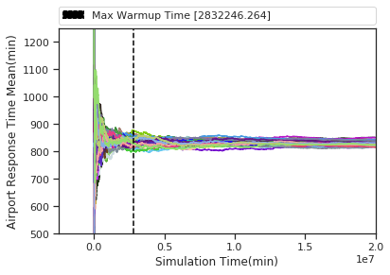

Statistics Distributions Fitting

As the following step of our study we determined, in exponential regime under the stability condition, the distribution families and where possible the parameters of the different statistics in the system, analysis which was carried out through the use of QQ-plots.

**Ingrandire e allineare R2 (paint.net)**

**Cambiare la <figcaption> in hypoexponential**

**Dire qualcosa in più sul MLE, almeno un riferimento in letteratura**

**Quanti seed? Parametri?**

|  |  |  |
| --- | --- | --- |
| **Holding Queue Size**  Geometric Distribution | **Depart Queue Size**  Geometric Distribution | **Parked Planes**  Poisson Distribution |
| **Holding Queue Waiting Time**  Exponential Distribution | **Depart Queue Waiting Time**  Exponential Distribution | **Airport Response Time**  Hypoexponential Distribution |

Once the families of the distributions were identified, we proceeded to estimate their defining parameters by using the **Maximum Likelihood Estimation (MLE)** method, as summarized below:

**Ricontrollare TUTTi gli estimated parameters**

|  |  |  |
| --- | --- | --- |
| Statistic | Distribution | Estimated Parameters |
| HoldingQueueSize  DepartQueueSize | Geometric | p = 1/ |
| HoldingQueueWaitingTime  DepartQueueWaitingTime | Exponential | λ = 1/ |
| ParkedPlanes | Poisson | λ = |
| AirportResponseTime | Hypoexponential |  |

|  |  |
| --- | --- |
|  |  |

Where some computation examples are shown below:

**Se possibile sostituire i nomi dei parametri con tA, tL, tP, tO e ingrandire**

**Perché i parametri di simulazione cambiano tra le varie grandezze?**

|  |  |  |
| --- | --- | --- |
| **Holding Queue Size** | **Depart Queue Size** | **Parked Planes** |
| **Holding Queue Waiting Time** | **Depart Queue Waiting Time** | **Airport Response Time** |

Where the following observation can be made:

* The *HoldingQueueSize* and the *DepartQueueSize*, as the *HoldingQueueWaitingTime* and the *DepartQueueWaitingTime* present the same distributions with approximately the same parameters, additional proof that logically the system behaves as having a single logical queue as depicted in the QT model.

**Sposterei dopo, o sezione finale direttamente**

* As will be further confirmed in the next section, the rate of the poissonian representing the parked planes is approximately equal to λ = tA/tP, which allows us to esteem the number of parked planes in the system and thus the size required by the parking area relaxing the constraint of it having an infinite airplane capacity.

2kr Factorial Analysis

As the next step in our analysis, to better understand the contribution of each parameter tA ,tL, tP and tO to the system statistics, we performed a 2kr factorial analysis with 250 independent replications for each configuration, for a total of 24*500 = 4000 simulations, whose results are outlined below (where the combinations of factors having a null contribution are omitted for clarity):

**Swing di parametri?**

Holding Queue Size (HQS)

|  |  |  |  |  |  |  |  |  |  |  |
| --- | --- | --- | --- | --- | --- | --- | --- | --- | --- | --- |
|  | q0 | qta | qtl | qta,tl | qto | qta,to | qtl,to | qta,tl,tot | qtp | other |
| **q** | 0.841 | -0.412 | 0.361 | -0.244 | 0.342 | -0.23 | 0.153 | -0.145 | 0.0008 | … |
| **SS** | 5.66e3 | 1.36e3 | 1.03e3 | 4.76e2 | 9.36e2 | 4.22e2 | 1.87e2 | 1.68e2 | 0.0056 | … |
| **Impact** | - | **29.58%** | **22.67%** | **10.37%**  **Cos’è SSY?** | **20.41%** | 9.19% | 4.09% | 3.67% | 0.00% | 0.00% |
| SSY = 1.02*104 | | | | SST = 4.59*103 | | | SSE = 0.901 (0.02%) | | | |

Depart Queue Size (DQS)

|  |  |  |  |  |  |  |  |  |  |  |
| --- | --- | --- | --- | --- | --- | --- | --- | --- | --- | --- |
|  | q0 | qta | qtl | qta,tl | qto | qta,to | qtl,to | qta,tl,tot | qtp | other |
| **q** | 0.829 | -0.408 | 0.391 | -0.255 | 0.312 | -0.218 | 0.165 | -0.149 | 0.0015 | … |
| **SS** | 5.5e3 | 1.33e3 | 1.22e3 | 5.2e2 | 7.77e2 | 3.82e2 | 2.18e2 | 1.78e2 | 0.018 | … |
| **Impact** | - | **28.73%** | **26.42%** | **11.24%** | **16.78%** | 8.25% | 4.71% | 3.84% | 0.00% | 0.00% |
| SSY = 1.01*104 | | | | SST = 4.63*103 | | | SSE = 0.905 (0.02%) | | | |

Holding Queue Waiting Time (HQWT)

|  |  |  |  |  |  |  |  |  |  |  |
| --- | --- | --- | --- | --- | --- | --- | --- | --- | --- | --- |
|  | q0 | qta | qtl | qta,tl | qto | qta,to | qtl,to | qta,tl,tot | qtp | other |
| **q** | 29.4 | -17.0 | 18.3 | -12.5 | 17.4 | -11.9 | 9.99 | -8.58 | 0.0427 | … |
| **SS** | 6.91e6 | 2.32e6 | 2.67e6 | 1.25e6 | 2.41e6 | 1.13e6 | 7.98e5 | 5.89e5 | 14.6 | … |
| **Impact** | - | **20.81%** | **23.91%** | 11.20% | **21.56%** | 10.09% | 7.14% | 5.27% | 0.00% | 0.00% |
| SSY = 1.81*107 | | | | SST = 1.12*107 | | | SSE = 2.25*103 (0.02%) | | | |

Depart Queue Waiting Time (DQWT)

|  |  |  |  |  |  |  |  |  |  |  |
| --- | --- | --- | --- | --- | --- | --- | --- | --- | --- | --- |
|  | q0 | qta | qtl | qta,tl | qto | qta,to | qtl,to | qta,tl,tot | qtp | other |
| **q** | 29.1 | -17.0 | 19.0 | -12.8 | 16.7 | -11.6 | 10.3 | -8.67 | 0.0791 | … |
| **SS** | 6.76e6 | 2.3e6 | 2.88e6 | 1.3e6 | 2.22e6 | 1.08e6 | 4.49e5 | 6.02e5 | 50.1 | … |
| **Impact** | - | **20.47%** | **25.60%** | 11.60% | **19.79%** | 9.60% | 7.55% | 5.36% | 0.00% | 0.00% |
| SSY = 1.8*107 | | | | SST = 1.12*107 | | | SSE = 2.25*103 (0.02%) | | | |

Parked Planes (PP)

|  |  |  |  |  |  |  |  |  |  |  |
| --- | --- | --- | --- | --- | --- | --- | --- | --- | --- | --- |
|  | q0 | qta | qtl | qta,tl | qto | qta,to | qtl,to | qtp | qta,tp | other |
| **q** | 1.71 | -0.303 | -0.015 | 0.008 | 0.0149 | -0.008 | -0.007 | 0.399 | -0.0997 | … |
| **SS** | 2.33e4 | 7.37e2 | 1.79 | 0.51 | 1.77 | 0.503 | 0.376 | 1.28e3 | 79.5 | … |
| **Impact** | - | **35.15%** | 0.09% | 0.02% | 0.08% | 0.02% | 0.02% | **60.82%** | 3.79% | 0.00% |
| SSY = 2.54*104 | | | | SST = 2.1*103 | | | SSE = 0.0373 (0.00%) | | | |

Airport Response Time (ART)

|  |  |  |  |  |  |  |  |  |  |  |
| --- | --- | --- | --- | --- | --- | --- | --- | --- | --- | --- |
|  | q0 | qta | qtl | qta,tl | qto | qta,to | qtl,to | qta,tl,tot | qtp | other |
| **q** | 1.83e2 | -34.0 | 44.7 | -25.3 | 41.5 | -23.5 | 20.3 | -17.3 | 30.1 | … |
| **SS** | 2.69e8 | 9.25e6 | 1.6e7 | 5.11e6 | 1.38e7 | 4.41e6 | 3.29e6 | 2.38e6 | 7.26e6 | … |
| **Impact** | - | **15.04%** | **26.02%** | 8.31% | **22.42%** | 7.17% | 5.35% | 3.87% | **11.8%** | 0.00% |
| SSY = 3.31*108 | | | | SST = 6.15*107 | | | SSE = 9.2*103 (0.01%) | | | |

The main insights that can be derived from the analysis:

**Qual’era il discorso sugli errori di tutti non distribuiti normalmente tranne i PP?**

* Most of the system statistics are affected with different weights only by the parameters involved in the stability condition (tA ,tL and tO), while the tP only affects the *Parked Planes* and to a minor degree the *Airport Response Time*.

**Spostare in sezione finale?**

* The *Parked Planes* statistic is affected only by the tP and the tA, where as discussed in the previous section the poissonian rate of the *Parked Planes* as its mean value is approximately

System Fairness Analysis

From the observation of their trends we noticed all system statistics (except for *Parked Planes*) to be strongly correlated, where localized delays or anticipations in any event in the system would cause such delay or anticipation to affect every other statistic, leading to shared trends alternating in time periods with spikes of high values, representative of a congested system, with periods with very low values, representative of an almost-empty system.  
This behaviour lead us to further investigate on the system’s fairness via the computation of the Lorenz Curve Gap and, following our analysis, we conclude the fairness to be affected by mainly two factors:

Number and likeliness of the influencing parameters (RVs)

We observed that the more a statistic is affected by multiple parameters, the more such statistic tends to present a higher level of fairness (or a lower LCG) with respect to other statistics influenced by less parameters.  
This behaviour can find explanation as an increasing influence of the Central Limit Theorem (CLT) on the statistics, where as the number of influencing RVs increases, so do their combined effects tend to a normal distribution, presenting an innate higher level of fairness with the respect to exponential distributions.   
We also observed that, for a given number of influencing RVs for a statistic:

1. The more their distributions are similar (i.e their defining parameters λi are close in value), the higher the statistic’s fairness, effect that once again finds explanation in the CLT.
2. The statistic fairness is not affected by the magnitude of the influencing RVs.

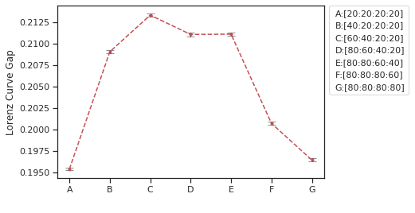Results that are shown in the following plot of the *Airport Response Time* by varying the parameters in the system

**Intestazioni grafico, nel caso se possibile rimuovere introduzione in giallo**

Utilization Factor ρ

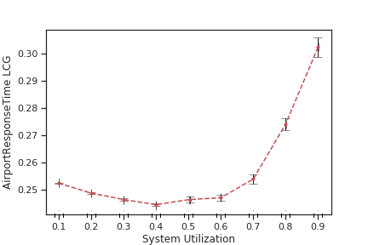We also observed the statistics’ fairness to be directly affected by the system’s utilization factor, where as it increases so does the LCG and so the unfairness, behaviour that can be attributed to the fact that the more the system is congested the more the delay at each of its stage tend to escalate, leading to chains of increasing delays.

**Io mi fermerei qui sui ragionamenti della Fairness.  
1) Quanto può essere accurato che diminuisca intorno a ρ=0.4?  
2) Il comportamento della dimensione delle code andrebbe a invalidare il precedente ragionamento, come si giustifica?**

**Migliorare intestazioni grafico**

**Cos’altro mettere del materiale?**

Conclusions

Scrivere conclusioni, o direttamente agglomerare qui la maggior parte degli insights dei punti precedenti, e qualche discorso su come aumentare le prestazioni del sistema, tra cui

1. Cercare di ridurre più possibile la randomness (cosa applicata nel reale, cioè ogni aereo ha un suo orario di arrivo e partenza, dove si cerca di limitare la varianza quanto possibile)
2. Possibilmente prevedere più code, dove (sicuramente?) il service rate del sistema cresce linearmente.

Si lascia perdere l’analisi del tempo di ritorno medio del sistema allo stato iniziale?

1. A mathematical analogy of the expression of the equivalent service rate can be found in electric networks theory as the equivalent conductance of the parallel of two conductances